**EIGHTS COMMISSION AGENCY PROJECT (ECA)**

* **Introduction**
* Project Summary

This project is a dynamic web application which will act as a commission agency or a bridge between people and facility service centers they need to work with. Their includes Homes to stay in such as Hotels, Motels, Lodges,.. and other facilities that provides daily services needed by the community such as Restaurant services, Vacation and Travelling agencies and so on .

* Problem statement
* In Rwanda, The tourism industry is boosting and growing on the high rate and proportionally the facilities to serve those tourists who are one of the biggest source of income for the country are being established; In fact, People to know where to get what they need, the wastage of energy, time and money is the problem due to the lack of strong means of information availability which is why the ECA Project is coming for.
* Objectives
* Develop a website that help people to know where to find services they wants remotely without time wastage.
* help the community to achieve economic development using this project.
* Project Rational
* The ECA project will be a solution and will act as an interface to the Travellers who wants to find homes away from their own homes
* The ECA project will act as a communication channel where Clients can communicate with Facility owners.
* The ECA project will also contribute in growing in names and market for Companies due to advertisement as the website grow and get known even more .
* **Methodologies and Methods**
* Data collection methodology

The problem was found by observing and using other similar websites where we found out that many Rwandan did not use website to locate their facilities, so we wanted to offer a website which was specifically designed for Rwandans and which is easy to use hence their activities will get known globally.

* Tools to be used
* Hardware tools

Required hardware tools for your this project:

* Admin computer or pc.
* Other computer component like(mouse, keyboard ..)
* Software tools

Required software tools for this project?

* Xamp (for local server).
* WINDOWS 10 or older.
* Vs code (in development phase)
* Browser (Chrome, Edge)
* Domain name for hosting
* Hosting plan
* Latest php
* **System Analysis and Design**
* Requirement Specifications
* Functional requirements
* User authentication
* User registering
* Mail sending
* Data Requirements

ECA ERD

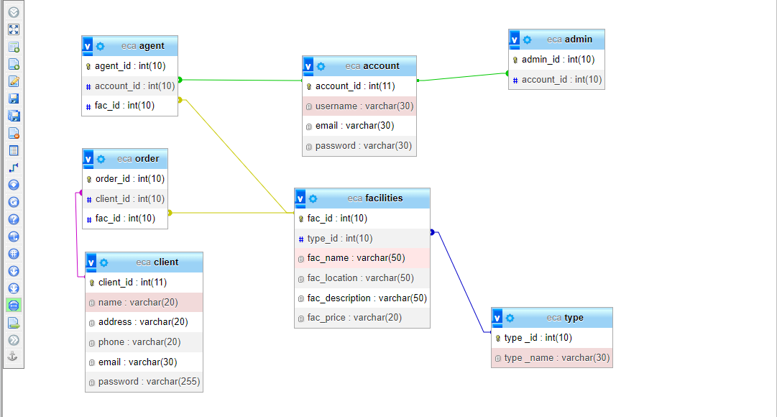

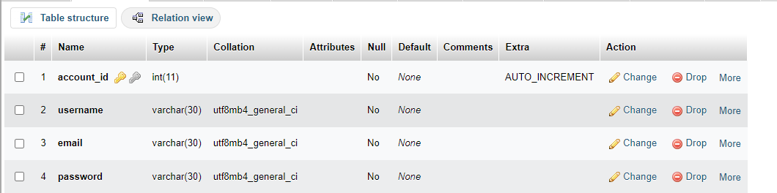

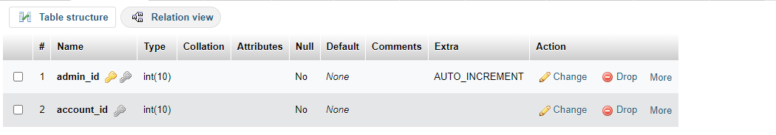

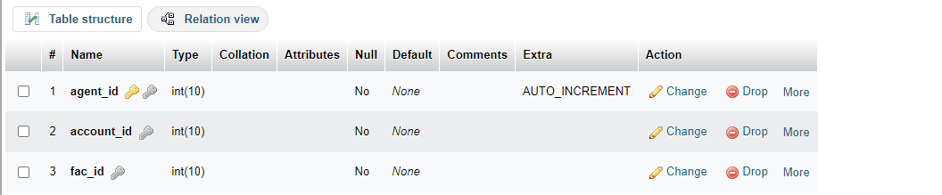

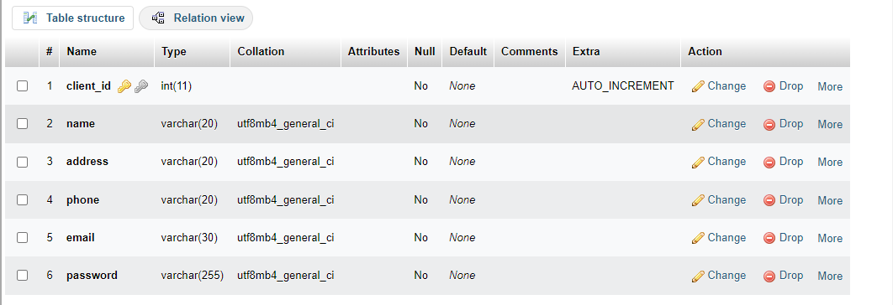

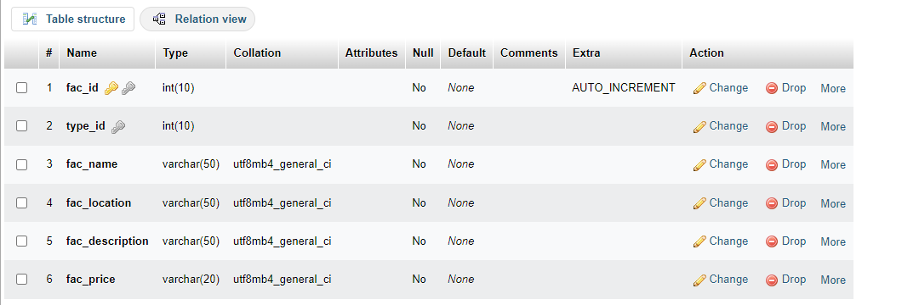

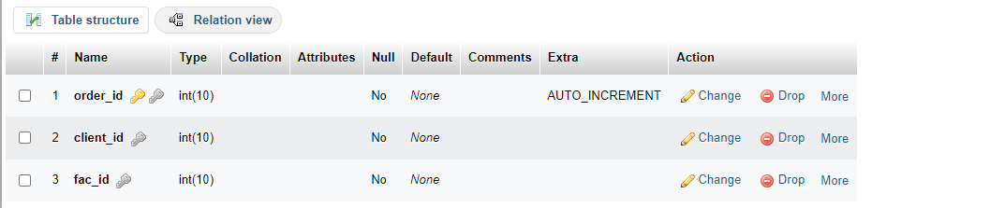

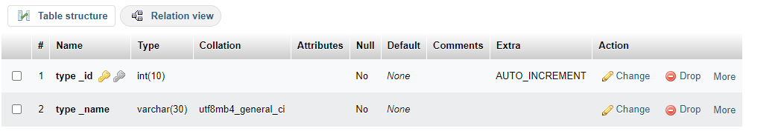

* User Requirements
* Admin
* Client
* Agent
* Security Requirements
* Password encryption.
* user restriction on some pages used by admin.
* Non-functional Requirements
* What is the system performance?

system performance is at 75%

* What is the system reliability?

system performance is at 80%

* What is the system accessibility?

system performance is at 70%

* What is the system scalability?

Normal

* System Design
* System overall architecture

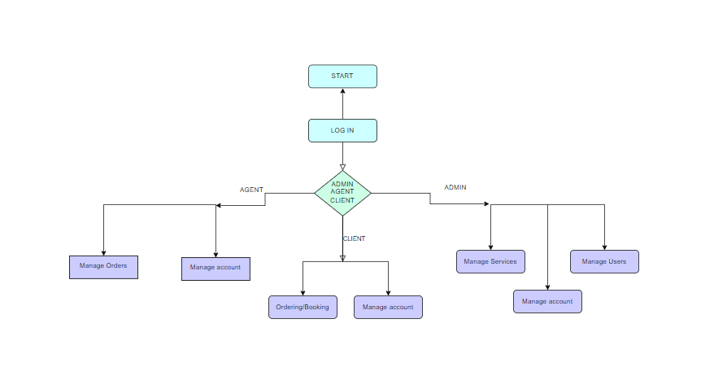

*Figure : Overall structure*

* System information flow
* LOGIN FLOW CHART

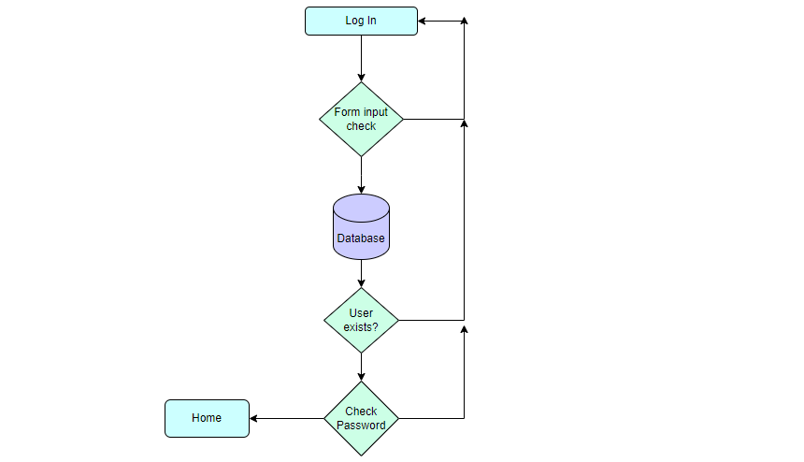

* USER SIGNUP FLOW CHART

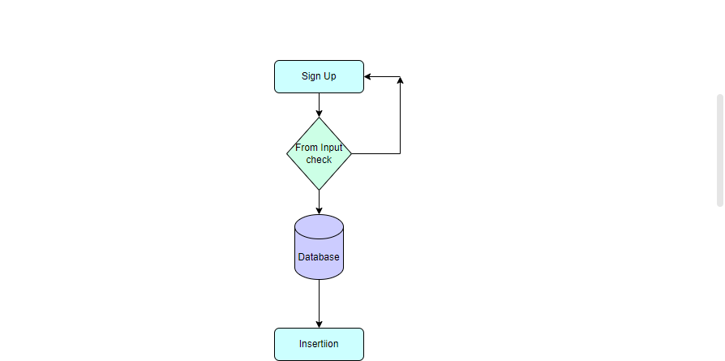

* System Implementation
* Home page

This picture detail the landing page of the ECA project. It contains the welcoming theme and a small website description, Login and Sign up buttons to allow a client to make orders, it also contains the images of available recommended facilities that a client could work on so that they can make reservations/bookings.

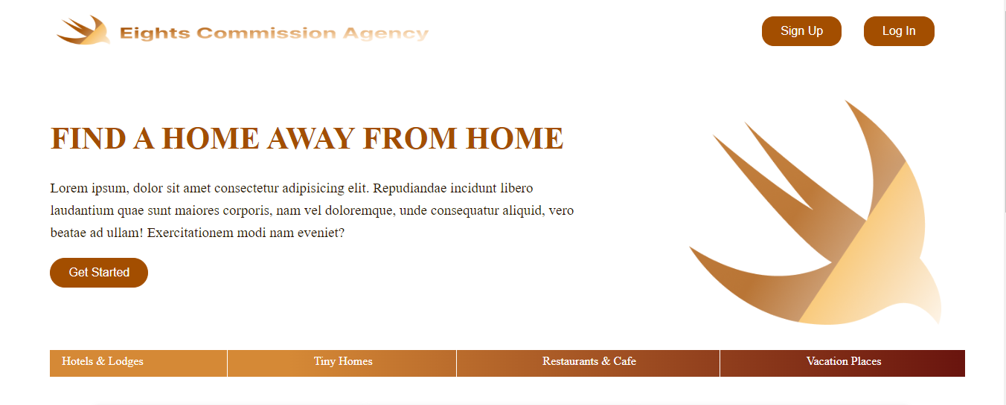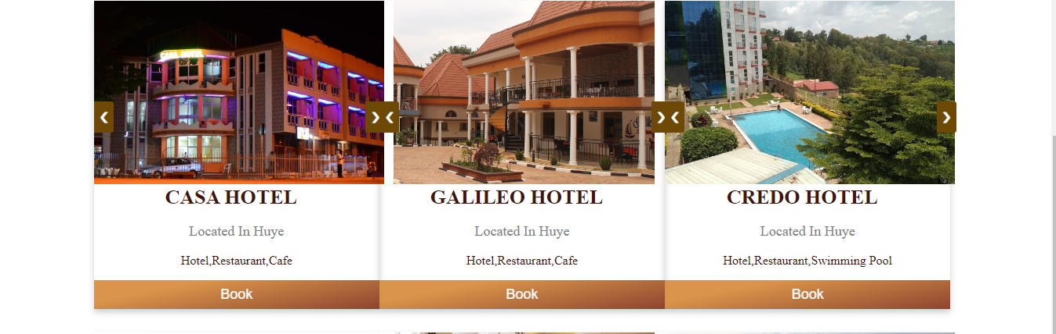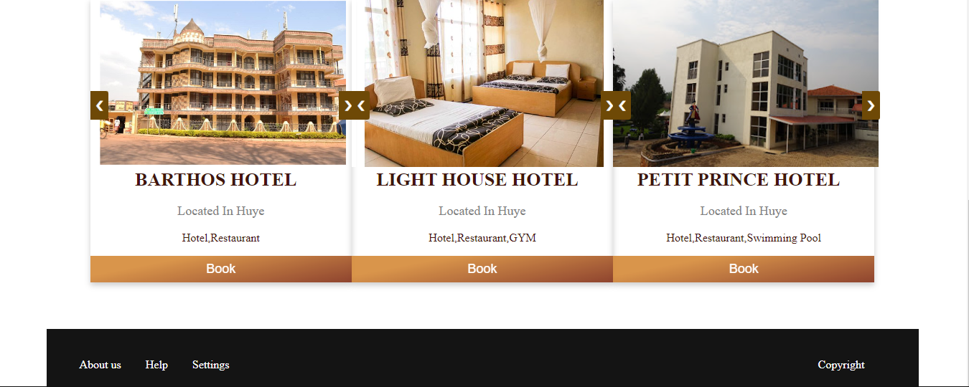

*Figure : Home page*

* Login Page/ Landing Page

This page detail the login process of the ECA project, where the user is required to enter the email and password so that they can be sent to the database for checking and if the user is not found an error is displayed at the top. In addition, if the user does not have an account an option to create one is given and then the user is redirected to sign up page.

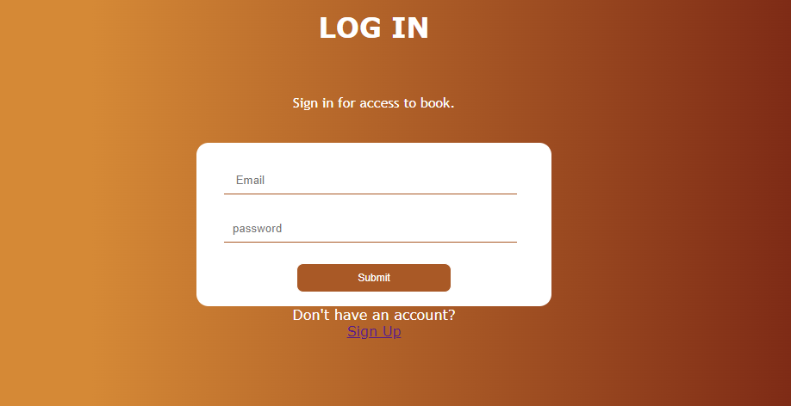

*Figure : Login page*

* Sign Up Page

This page detail the Sign up process of the ECA project, where the user is required to enter all of the required information in order to create an account so that they can be sent and inserted into the database.

if an error occurs during this process a message is displayed at the top.

In addition, if the user already has an account, a message displays mentioning that the account is already there so that they log in instead.

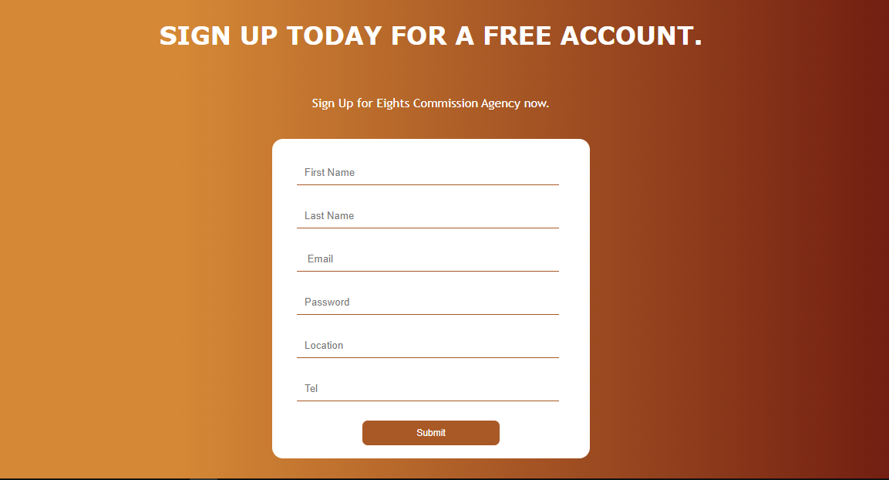

*Figure : Signup page*

* Conclusion
* In conclusion, this project is still ongoing and it is at 60% completion
* There are some of the features missing such as the links from the footer and mainly the administration interface which would be different from the client’s.
* Based on the current progress, it is seen that the project will be able to solve the problem mentioned above and will contribute to the development of the community.
* Recommendation
* **Lessons learned**.
* Every project needs an objective and mission, a design flow, planning and many other resources in order to continue to development phase.
* Before starting a project, all languages and softwares which will be used must be compatible with each other and updated to latest version
* Javascript (used for adding making elements lively), php (used to interact with database),html (used to structure web pages), css (used to style webpages) work really well together.
* hard work and patience are needed to work on every project.
* **What do you recommend:**
* **Other students**
* Continue working on these projects and increase their knowledge.
* **Department**
* Increase hours dedicated to web Technology module**.**
* **Beneficiaries of your project proposal**
* **TO ENTREPRENEURS**

Use this website to advertise their work.

provide authentic/real information about them.

* **TO CLIENTS**

Make sure that information provided are secured just for your safety.

* Appendix

GITTHUB: https://github.com/nioctave/ECA_Project